Antibiotics, aminoglycosides, macrolides.
Aminoglycoside antibiotics play an important role in the treatment of infectious diseases. The first representative of this group is streptomycin, isolated in 1943. Synthesis was performed by Waksman.
Most aminoglycoside antibiotics are in the form of a sulfate salt. The pka value of these salts is 7.5 to 8. They are not absorbed when ingested. At the same time, they are not resistant to gastric acid. It is applied parenterally or locally as a sulfate salt. These features should be taken into account when preparing dosage forms of these antibiotics. Since they are hydrophilic compounds, they do not bind to plasma proteins. Candidate glomerular filtration is observed in these preparations. They cause loop toxicity as a result of excessive ionization. Thanks to their cationic molecular structure, they show a special avidity to the epithelium of the loop. Since urine has an acidic reaction in the primary filtrate, complete protonation occurs. This protonated form ensures dissociation. Nephrotoxicity occurs as a result of this pharmacokinetic event. Nephrotoxicity of the drug is directly proportional to the kinetic distribution. Nephrotoxicity develops together with ototoxicity. Because the accumulation of aminoglycoside antibiotics in the inner ear nerve is directly proportional to the decrease in excretion from the kidneys. This ratio mainly depends on the change in ph. For example, an antibiotic with pka=7.5 is more difficult to distribute in plasma with ph=7 than in plasma with ph=7.4. Because the protonated form at ph=7 is 20% larger than at ph=7.4. The half-life period from plasma fluctuates within 2-3 hours. Kidney function is very effective in renal elimination of the drug and changing its excretion from the body. Nephrotoxicity is observed as a result of their accumulation in the tissue. Conjugation metabolites such as N-acetylation, N-phosphorylation and N-sulfation are formed during their biotransformation. They are excreted from the body (80-90%) with urine.
Gram (+) and gram (-) are broad-spectrum antibiotics because of their action against bacteria. They mainly affect gram (+) bacteria. They inhibit protein biosynthesis, acting on the 30-S subunit of bacterial ribosomes. Antibiotics have a bactericidal effect. These compounds accumulate in the ribosome binding region and inhibit bacterial translation. They cause the formation of an irregular chain of amino acids. Thus, the bacterial membrane cannot perform its function. The cytoplasm bursts out, and the bacterium dies. Of them, only cypectinomycin has a bacteriostatic effect. It affects bacterial protein biosynthesis and prevents translocation. But others are bactericidal, because they act directly on the membrane.
The development of resistance occurs during the synthesis of metabolizing enzymes as a result of the rapid development of genetic information in bacteria. This biosynthesis is analogous to reactions of biotransformation in humans. These enzymes that inactivate aminoglycoside antibiotics by bacteria are aminoglycoside acyltransferases, aminoglycoside phosphate transferases and aminoglycoside nucleotide transferases.
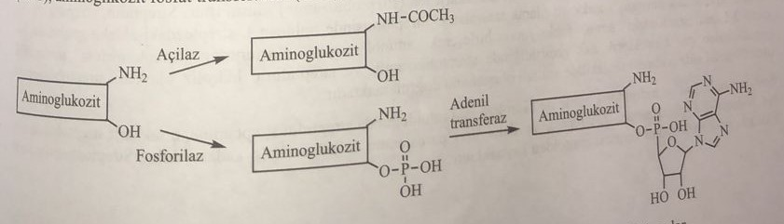
The use of β-trelactan antibiotics in the clinic for the regulation of their oral absorption has a synergistic effect on the absorption of aminoglycoside antibiotics into the bacterial cell. At the same time, some diuretics increase the ototoxic effect. Therefore, it cannot be used with diuretics. Amphotersin-B, when used together with nephrotoxic compounds, such as cisplatin, has a synergistic nephrotoxic effect.
The main structure of aminoglycoside antibiotics is aminocyclotol (aminocyclohexanol). With aminocyclotol, aminos form a glycosidic bond, called an ozid bond. Therefore, this group of antibiotics is also called aminocyclitol glycosides. The chemical structure of the antibiotic consists of cyclitol and saccharide. This group of antibiotics is a strong basic compound containing alkylamine and hydroxyl alcohol as functional groups.
The sugars found in this group of antibiotics are very diverse, the aglycon aminocyclites with which they are combined have 4 different structures: streptamine, streptidine, 2-deoxystreptamine and fortamine.
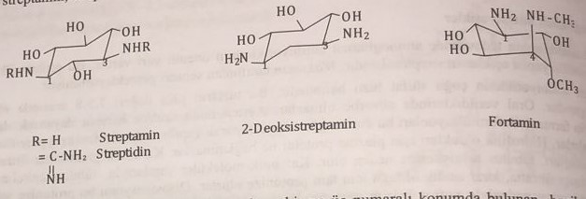
All of them have a cyclohexane structure connected to hexane. Primary amino groups in the first and third positions have an equatorial configuration.
In fortamine, the amino group in the first position is equatorial, and the amino group in the fourth position and the methoxy group in the third position have an axial configuration.
While the names of antibiotics obtained from Streptomyces species (streptomycin and neomycin) end with the suffix "icin", the names of antibiotics obtained from other types of microorganisms, such as Mycromonospora (gentamicin, amicocin, netilmicin), end with the suffix "icin". Since the member of the aminocyclite structure, which is basically an aglycon, is included in the classification of saccharides in chemistry, these antibiotics are studied in 3 structures according to the number of monosaccharides attached to this aglycon, and they are called pseudooligosaccharides.
1) Disaccharide aminoglycoside antibiotics (glycon + aminose)
2) Trisaccharide aminoglycoside antibiotics (glycon + two amino acids)
3) Tetrasaccharide aminoglycoside antibiotics (glycon + three amino acids)
Streptidin group of antibiotics
Streptomycin
This is the second antibiotic after penicillin G, isolated from the culture of Streptomyces griseus. It consists of streptidine and disaccharide (streptobiosamine) connected to it in the fourth position. The amino group of streptidine streptose and N-methyl-2-L-glucosamine were combined to form an amino structure. Streptomycin hydrolyzes to streptobisamine and streptidine when passing gaseous hydrogen chloride through a methanol solution. The output of dimethylacetal of streptobiosamine confirms the presence of aminol in the molecule.
During hydrolysis with sodium hydroxide and hydrochloric acid, streptidine is split into streptamine, and the disaccharide streptobiosamine is split into N-methyl-2-L-glucosamine, L-streptose and maltol. The color reaction of streptomycin with iron chloride 3 is based on maltol.
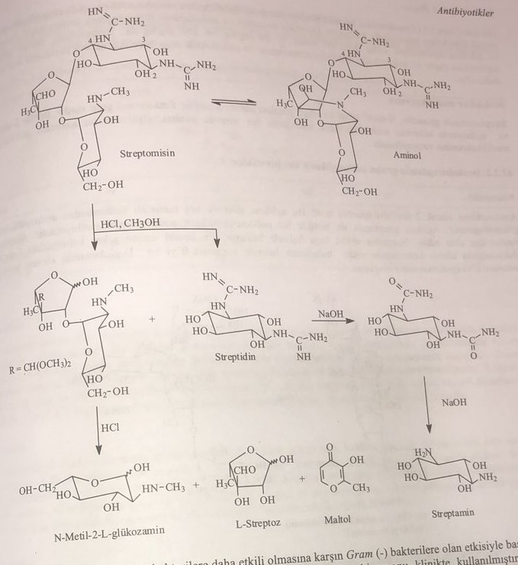
Considering that penicillin is more effective against gram(+), and streptamycin is more effective against gram(-) bacteria, a combination of these two drugs was prepared and used in clinical practice. At the same time, it is effective against the tuberculosis bacillus. This is the most important antibiotic against Pasteurella tularensis infection.
Since streptomycin is poorly absorbed from the gastrointestinal tract, it is administered parenterally. When hydrogenating streptomycin, the aldehyde group in L-streptose is restored to a monoatomic alcohol, and thus dihydrostreptomycin is obtained. However, the absorption of this compound is similar to streptomycin.
Since the value of LD 50 of streptomycin is low, the therapeutic index is narrow. As side effects, nephrotoxicity and ototoxicity are observed. Basically, these side effects are observed in practically all aminoglycoside antibiotics, but the ototoxic effect is higher than that of streptomycin. Since dihydrostreptomycin is formed as a result of reductive biotransformation caused by bacteria, this derivative also accumulates in auditory nerves. This toxicity is permanent, especially in children. This side effect is observed when first the auditory nerve (cochlear nerve) is depressed, and then the balance nerve (vestibular nerve). Dihydrostreptamycin is more active than streptamycin. Streptamycin contains two guanidine, one methylamine and three basic groups in the molecule. Easily forms salts with mineral acids. The most widely used sulfate salt, formed by sulfuric acid. Active against many gram(-) bacteria.
Molecular modification
Streptomycin guanidine has three functional groups in its molecule: N-methylamino and alcohol hydroxyl. They undergo coupling reactions with S-alkylation and acylation. But since a decrease in antibacterial activity was observed in these obtained derivatives, the modification was not widely distributed.
Antibiotics of the aminoglycoside group of deoxystreptomin
Neomycin
As an aminocyclite, 2-deoxystreptomin retains its structure. This aglycon is glycosidated with aminosaccharides in the fourth and fifth positions. Aglikon, together with streptomin, is considered a pseudotetrasaccharide aminoglycoside antibiotic. It is obtained from Streptomyces fradiae culture. Neomycin is used in the form of a sulfate salt. Neomycin E is formed by the combination of neomycin B and D-glucosamine during the binding of the amine in the sixth position of the most terminal residue of the amino sugar 2-deoxy-D-glucosamine.
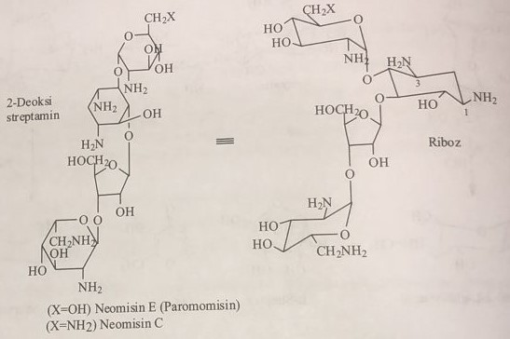
Gram(-) bacteria are mostly affected. Not active against Pseudomonas aeroginosa. Active against mycobacterium tuberculosis strains. It has very high ototoxic and nephrotoxic effects. Therefore, it is widely used in the form of vaginal suppositories and ointments. When used orally, the drug behaves as an intestinal antiseptic.
Paromomycin
Unlike the neomycin molecule, it contains 2,6-dideoxy-D-glucosidiamine in its structure. According to various literature data, the second disaccharide fragment, derived from ribose and 2,6-dideoxy-D-glucosediamine, is the same as that of neomycin. Active against gram (+) bacteria, such as neomycin. It is used as an oral intestinal antiseptic.
Livomycin A
The difference from paromomycin is the addition of D-mannose to the fifth position of 2,6-dideoxy-D-glucosediamine attached to D-ribose. Lividomycin A is a pentasaccharide that acts like paromomycin and neomycin.
4,6-diproizvodnye-2-deoxystreptamine aminoglycosides group of antibiotics
This group includes kanamycin, dibekacin, gentamicin, tobramycin and amikacin among important antibiotics with a pseudotrisaccharide structure.
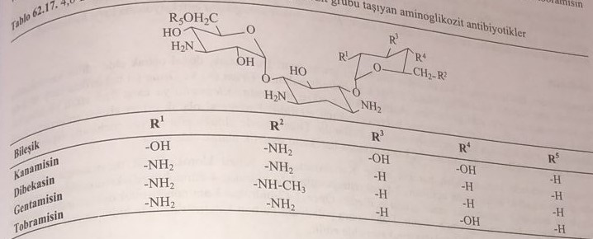
Kanamycin
3-D-glucosamine (kanosamine) is attached to the fourth position of 2-deoxystreptamine, and 6-deoxy-D-glucosamine is attached to the sixth position. This compound is called kanamycin A, and if this residue is 2-deoxyglucosamine, it is called kanamycin C. It is mainly used in the form of sulfate salt. It has a weak effect on gram(+) bacteria and a strong effect on gram(-) bacteria. At the same time, it is active against mycobacteria. It is used as streptomycin. It is mainly used parenterally, locally and orally as an intestinal antiseptic.
Dibekasin
This compound from the group of 4,6-diprovided 2-deoxystreptamine is used in the form of a sulfate salt. 3-D-glucosamine is added to the fourth position of streptamine, and 2,6-diamino-3,4-deoxy-D-glucose is added to the sixth position. Also called pseudotetrasaccharide. Active against gram(+) and gram(-) bacteria, especially against bacterial strains that have acquired resistance to aminoglycosides. It is used for infectious diseases of the urinary and respiratory tracts. At the same time, it is recommended to use it for septicemia and endocarditis.
Gentamicin
2-deoxystreptamine has garosamine in the fourth position and purpurosamine A in the sixth position. It is obtained from the culture of Micromonospora purpurea and M. echinospora. Purpurosamine A, 3,5-dideoxy-2,6-diaminohexose, has different names depending on the conjugated radicals.
It is used in the treatment of infectious diseases caused by both gram(+) and gram(-) bacteria. It is used for severe infections, sepsis, endocarditis and osteomyelitis. Its use in combination with cephalosporins of a wide spectrum of action leads to a better therapeutic effect. Like other aminoglycoside antibiotics, it is currently used topically.
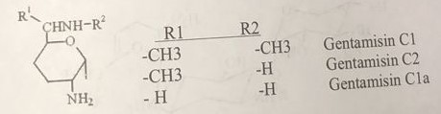
Tobramycin
2-deoxystreptamine is attached to 3-D-glucosamine (kanosamine) in the fourth position and to 2,6-diamino-3-deoxyhexose (neobrosamine) in the sixth position. It is used in the form of sulfate salt. Active against gram(+) and gram(-) bacteria. It is used to treat bacterial infections resistant to gentamicin. It is used against Pseudomonas aeruginosa infections.
Amikacin
Unlike kanamycin, it retains the 2-hydroxy-4-aminobutyryl group. This compound is a semi-synthetic compound synthesized from the naturally occurring kanamycin. It is used in the form of sulfate salt. Amikacin is used to treat severe nosocomial infections caused by resistant gram-negative bacteria, such as Pseudomonas aeruginosa, Acinetobacter, Enterobacter, Serratia marcescens and Providencia stuartii. Amikacin can also be used for the treatment of non-tuberculous mycobacterial infections and for the treatment of tuberculosis when first-line drugs are ineffective. Amikacin is used in combination with beta-lactam antibiotics for empirical treatment of neutropenic fever.
Kanamycin is used for the synthesis of the compound. Kanamycin first reacts with benzylchlorcarbonate to acylate the amino group of 6-aminoglucosamine. The synthesis reaction looks like this:
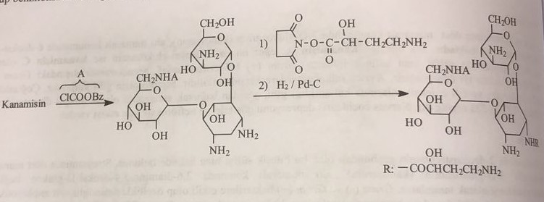
Sizomicin and Netilmicin
Sisomycin belongs to the group of 4,6-derived 2-deoxystreptamines. Garozamine, like gentamicin, is attached to the fourth position, and 4,5-dehydropurpurosamine C, obtained from 4,5-dihydro-2,3,4-deoxy-6-aminohexose, is attached to the sixth position. It is obtained from the culture of Micromonosporo inyoensis.
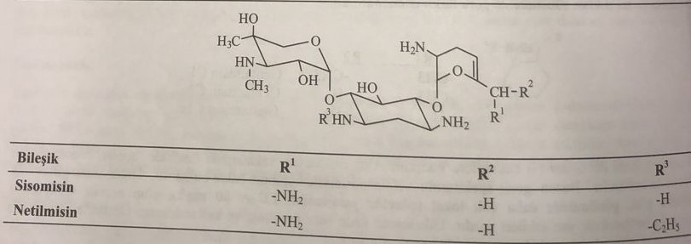
Netilmycin is obtained from sisomicin by reductive aminoethylation by the reaction of acetaldehyde-formic acid. The pharmacokinetic properties of netilmicin are better than those of sisomycin.
Other antibiotics of the group of aminoglycosides are aminocyclitol
Studies of cultures of Micromonospora and Streptomyces since the 1970s allowed to obtain many aminocyclitol aminoglycoside antibiotics. The most important representatives are fortimicin and spectinomycin.
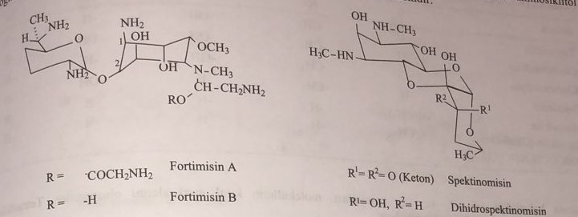
Both are active against gram(+) and gram(-) bacteria. It is used in the treatment of gonorrhea. Spectinomycin is used to treat gonorrhea in patients with penicillin allergy. Absence of ototoxic action. They are partially nephrotoxic. Like other aminoglycoside antibiotics, they have bacteriostatic rather than bactericidal action.
Tetracyclines
After penicillin and streptomycin, the first representative of this group is chlortetracycline, which was included in treatment in 1947. It was isolated as a secondary metabolite from Streptomyces aurefaciens culture. Because of the golden-yellow color, it is sold under the name Auromis. In 1949, oxytetracycline was isolated from Streptomyces rimosus and entered the market under the name terramycin.
Structure and chemical properties
This is a tetracyclic structure obtained from naphthacene by the reaction of partial reduction and oxidation. The following formulas indicate the numbering system of molecules containing basic chromophoric groups, combined functional groups and asymmetric centers. In this formula, the asymmetric centers are marked with an asterisk, and the chromophoric groups are shown in the frame. Of the rings in the tetracyclic structure, ring A is a dihydro, rings B and C are reduced to tetrahydro, and ring D is aromatic.
States 4, 4a, 12a form chiral centers due to the asymmetric carbon atom. States 1, 5, 6 and 11 are prochiral. That is, it can turn into a chiral center when combining any radical. Chiral centers can be obtained by reduction in the first and eleventh states and substitution in the sixth state.
Tetracyclines are obtained by acetogenic biosynthesis from Streptomyces culture. States 1, 2, 10, 11, 12, 12а, in which there are oxygen groups, and states а, 5, 6, 7 are suitable for substitution
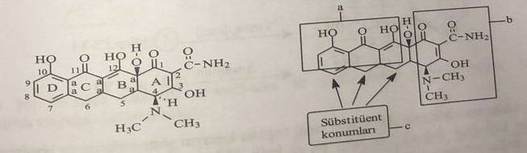
In tetracycline derivatives used in treatment, while the main ring structures A and B remain stable, new derivatives are obtained by performing various substitutions in the C ring. According to the saturated structure of the substitution in the fifth and sixth states can be α (axial) and β (equatorial). Substituted functional groups are shown in the table.
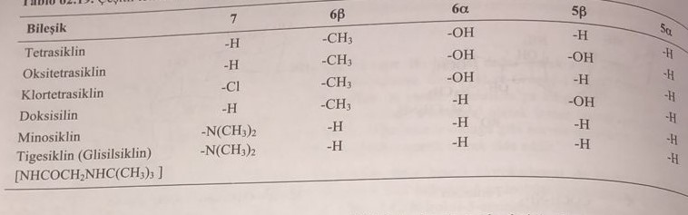
As shown above, states 4, 4a, 12a form the chiral centers of the molecule. The configurational structure of tetracyclines is shown below.
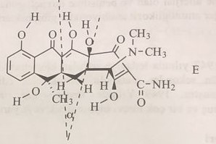
In this formula, not a single ring, except ring D, is directed towards the plane. A certain angle is formed between planes С-5а and С-11а and planes С-4а and С-12а. In tetracycline, in addition to 4, 4a and 12a, all asymmetric centers formed in the 5a and sixth positions have the S-configuration.
Tetracyclines are amphoteric compounds. Three different pka values were determined for the molecule. The enol hydroxyl group in the third and sixth positions of tetracycline and the dimethylamine group in the fourth position provide amphotericity.

This key feature leads to pH-dependent distribution and biopharmaceutical properties of all tetracyclines. Depending on the pH, the change in their dissociation and solubility in water is analogous to the change in amino acids. Therefore, it is possible to talk about the isoelectric point in these compounds as well as in amino acids.
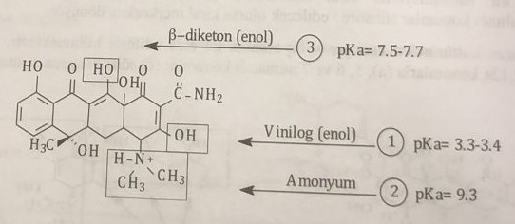
This key feature leads to pH-dependent distribution and biopharmaceutical properties of all tetracyclines. Depending on the pH, the change in their dissociation and solubility in water is analogous to the change in amino acids. Therefore, it is possible to talk about the isoelectric point in these compounds as well as in amino acids.
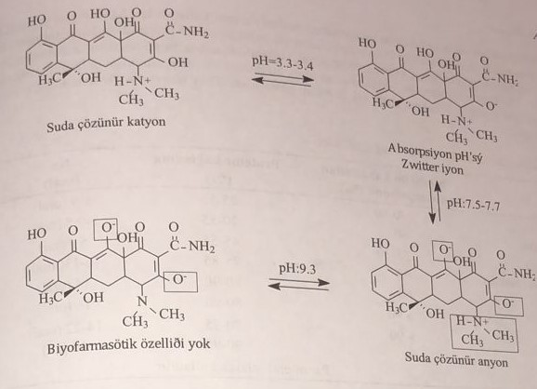
Almost all tetracyclines are used in the form of a hydrochloride salt. The following conditions must be met for oral bioavailability:
1) The optimal pH should be 2 for dissolution in gastric juice. At this pH, the compound is ionized to Tamil and becomes hydrophilic. Absorption is quite low.
2) The solubility of the zwitter (hybrid) ion form is low. Isoelectric point ph=5.5, solubility increases in lipophilic solvents. At the same time, absorbency is at a very high level.
3) In the case of anionic transition, after pH=7, solubility in water begins to increase again, and absorption again becomes low. Such a situation indicates that absorption occurs in the small intestine.
Tetracyclines do not have significant differences in acidity constants. The solubility in lipids is the same for chlortetracycline, oxytetracycline, tetracycline, but significantly higher for deoxycycline and minocycline. Minocycline has dimethylation in the seventh position. The sixth and fifth states do not have an attached functional group. Consequently, lipophilicity increased. When we compare tetracycline, which is a spatial isomer of doxycycline, with doxycycline, polar groups, such as the hydroxyl group at C12a, the cationic group at C4 and the hydroxyl group at C6, are not in the same plane. Although this situation does not explain absorption, it explains some kinetic properties of doxycycline. Differences in the structure of tetracycline and doxycycline are indicated in the figure and in the table below.
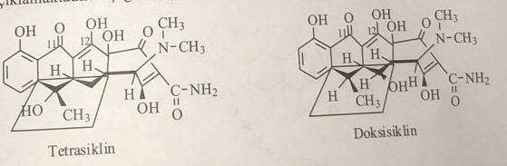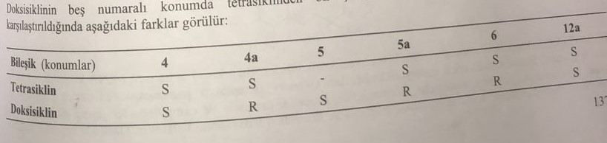
The low solubility of tetracycline antibiotics in water facilitates their oral absorption. Rolitetracycline, a semi-synthetic derivative, is used parenterally. Oil solution for injections is prepared with polyvinylpyrrolidone. The injection of these preparations is very painful. When used orally, they are quickly absorbed from the gastrointestinal tract. Their half-life periods are quite long. Tetracyclines are better distributed in lipophilic tissues. Pharmacokinetic properties of these derivatives are listed in the table below.
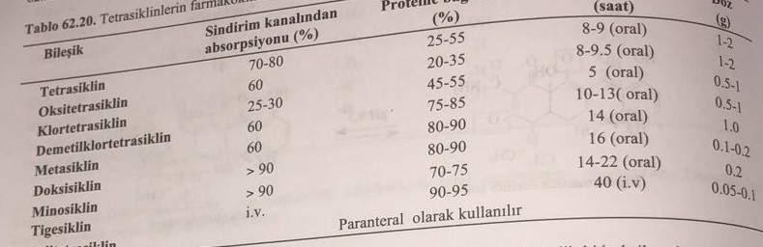
Tetracyclines form chelates with divalent and trivalent metals through the carbonyl group in the eleventh position and the enol hydroxyl group in the twelfth position. These chelates are very difficult to dissolve in water. Chelates are ineffective compounds because they are not absorbed through the bacterial membrane. At the same time, chelates are not absorbed from the gastrointestinal tract. With the exception of doxycycline, it is partially absorbed in the form of chelates. The semi-synthetic derivative of tigecycline is a new derivative synthesized to prevent the development of resistance.
Tetracyclines should not be used together with magnesium and aluminum antacids. At the same time, its use with dairy products rich in calcium is limited. When preparing medicinal forms such as tablets and capsules, fillers such as talc and thickeners such as magnesium stearate should not be used. Because if chelation is formed with metal ions, the drug is not absorbed from the gastrointestinal tract. Tetracyclines enhance the effect of coumarin derivatives and sulfonamides. Indirectly, this also increases the toxicity of these preparations. Tetracycline, methotrexate and cyclosyporin should not be used together. The toxicity of these preparations may increase. Especially such combinations should not be used in patients with renal and hepatic insufficiency.
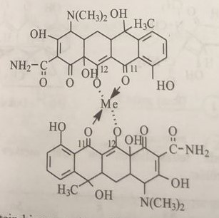
Especially when tetracycline is given to children, it accumulates in the form of calcium chelate in bones and teeth. Therefore, the use of this drug is contraindicated in any period of pregnancy and for children under 8 years of age. Forming a complex with zinc, which forms the active center of the enzyme callogase, it exerts a strong inhibitory effect on enzymes. When used for a long time, it causes photodermosis as a result of absorption at 360-370 mm due to the properties of the chromophore.
Tetracyclines affect the synthesis of ribosomal proteins of bacteria. It performs this effect by blocking the aminoacyl RNA complex. It affects both gram(+) and gram(-) bacteria. In clinical practice, they are mainly used in the treatment of rickets and chlamydia. It is used in the treatment of acne, especially observed in adolescence. Since minocycline is lipophilic, it is used in the treatment of some mycobacterial infections and acne.
Doxycycline and minocycline are 75% absorbed in the small intestine and distributed throughout the body. Here it accumulates, forming a chelate with calcium in the bones. The half-life period of the drug is 12-24 hours.
Antibiotics of the tetracycline group chlortetracycline, oxytetracycline, tetracycline and demethylchlortetracycline are obtained by biosynthetic fermentation. Metacycline, doxycycline and minocycline are also available in a semi-automatic mode using oxytetracycline. A double bond between N-chlorosuccinimide and states 11α-12 is introduced here. After removing water, 6-methylene, 11α-chloro, 12-ketogroups are formed. Doxycycline is obtained by reducing sodium tetrathionate and adding thiophenol to the methylene group in the sixth position of metacycline. At the same time, minocycline is obtained first by nitration of 6-demethyldeoxytetracycline, and then by reactive methylation.
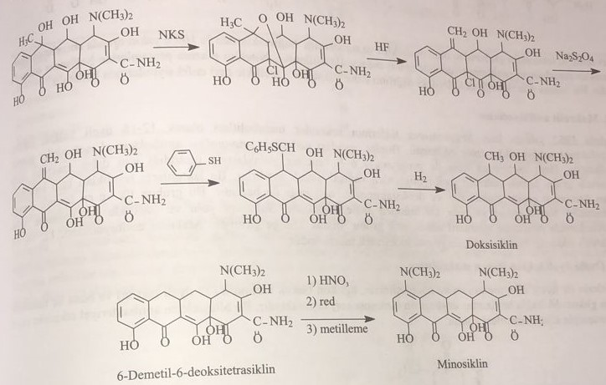
Rolitetracycline is obtained as a result of the Mannich reaction of the amino group in the third position of tetracycline with pyrrolidine and formaldehyde.
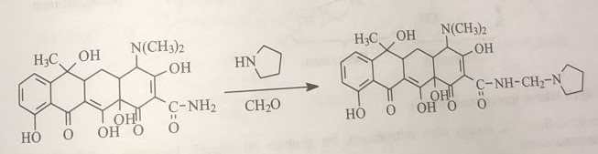
Tigecycline: (4S,4aS,5aR, 12aR)-9-[[2-(tert-butylamino)acetyl]amino]-4,7-bis(dimethylamino)-1,10,11,12a-tetrahydroxy-3,12 -dioxo-4а,5,5а,6-tetrahydro-4Н-tetracene-2-carboxamide
Monocycline is used for the synthesis of tigecycline. First, the ninth state is nitrated with nitric acid in a sulfuric medium. Tigecycline is obtained by the reaction of the derivative amine, formed by the reduction of the nitro group with acetic acid, iron powder or gaseous hydrogen in the presence of the PdC catalyst, with N-tert-butylglycinyl chloride.
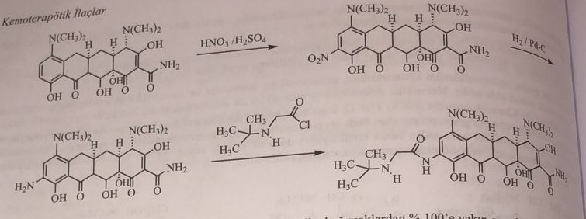
While doxycycline and minocycline from the group of semisynthetic tetracyclines are absorbed from the intestines up to 100%, tigecycline is practically not absorbed. Therefore, this drug is administered intravenously. In exceptional cases, the accumulation of the drug in fatty tissues is high. It is especially used for skin infections.
Macrolide antibiotics
For the first time in 1952. 12-16-membered lactone antibiotics, which are secondary metabolites, were isolated from Streptomyces species. From a structural point of view, they are called enonpolyene antibacterial macrolides. The second macrolide, amphotericin, is separated from polyene macrolide antibiotics, because it is produced both by acetogenesis and by the enzyme propionyl-CoA-synthetase. Different aminos and deoxyaminoses are connected with some hydroxyl groups of these lactones with the help of ozid bonds. The first and most important representative of this group is erythromycin. Streptomyces erythreus was isolated from culture. It is used as an alternative to penicillins in infectious diseases of the respiratory tract and upper respiratory tract. Macrolide antibiotics are divided into three groups: 12-, 14-, and 16-membered lactones.
Macrolides with a 12-membered lactone ring
Methymycin and neomethymycin, the first representatives of macrolides, consist of methinolite (12-membered lactone) as an aglycon and desosamine (amino sugar) in combination with a glycosidic bond in the third position. Due to the weak antibacterial action of these compounds, they are not used in clinical practice.
More about this source text The source text is quoted for additional translation information
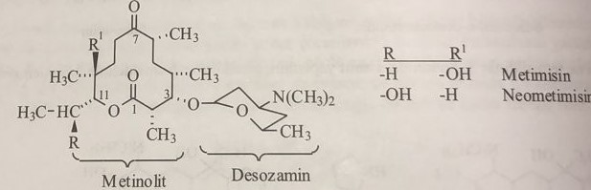
Macrolides with a 14-membered lactone ring
Erythromycin, the first representative of 14-membered macrolides, is the most important compound of this group. Some structural features of the connection are as follows:
1) 14-membered lactone (erythritol) has a ketone attached to C-10.
2) The sugar is connected to the aglycon with two glycosidic bonds in positions C-4 and C-6. Clanidose is connected with an α-glycosidic bond in the C-4 position, and desosamine (amino sugar) is connected with a β-glycosidic bond in the C-6 position.
3) The hydroxyl group is attached to the seventh, twelfth and thirteenth positions.
4) Methyl groups attached to positions 3, 5, 7, 9, 11, 13 show that erythromycin is not just a secondary metabolite, a product of acetogen biosynthesis, and propionic acid is also used by a microorganism in this biosynthesis.
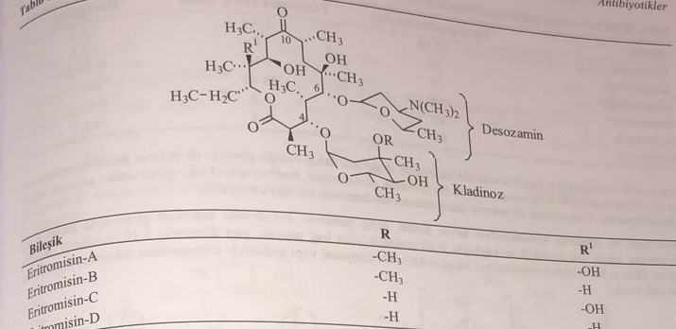
In many pharmacopoeias, the numbering of compounds begins with the oxygen atom of the lactone ring. In some sources, the numbering begins with the carbonyl group.
Because of its low solubility, erythromycin is not bioabsorbed to any degree when taken orally. The stability of aqueous solutions is low. At the same time, the bitter taste of the compound limits its oral use. The hydroxyl group in the second position of desosamine increases the stability of erythromycin due to the acylation of aminose in the sixth position. At the same time, the taste and bioabsorption properties of the compound are improved. Thus, in addition to oral administration, compounds suitable for parenteral administration are obtained. Erythromycin is used in the form of succinate, ezolate and lactobionate esters. Ethyl succinate is the most suitable among them. This ether is used in the preparation of suspensions in pediatric preparations.
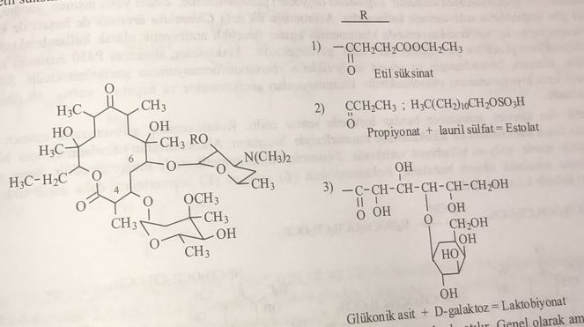
The half-life of erythromycin is two hours. Most of the metabolites are released into the intestine with bile. N-demethylerythromycin, which is mainly formed by N-demethylation from aminose, has no antibacterial activity. The triple amine structure is important for antibacterial action. Theophylline, carbamazepine, methylprednisolone, etc. It interacts with drugs. By preventing their oxidation, it causes an increase in the half-life.
To improve the physicochemical and pharmacokinetic properties of erythromycin, semi-synthetics such as clarithromycin (7-methoxy derivative), roxithromycin (10-oxime ester derivative), dirithromycin (10-12 ester oxide aminal derivative), azithromycin (addition of nitrogen atom between 10-11) derivatives were obtained and included in the treatment.
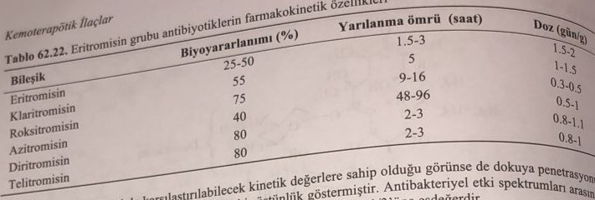
The tissue distribution of clarithromycin is better than that of erythromycin. There is not much difference between the spectrum of antibacterial action. The dose of semisynthetics is equal to 1/3 of the dose of erythromycin.
The ketone group in the tenth position of erythromycin undergoes intramolecular catalysis with the hydroxyl group in the thirteenth position. A double bond is formed between the 9th and 10th carbons with the release of a molecule of water. Irreversible 7-10 chemical structures are formed. These active derivatives have no antibacterial effect. Because of this chemical structure, erythromycin must be stored very carefully.
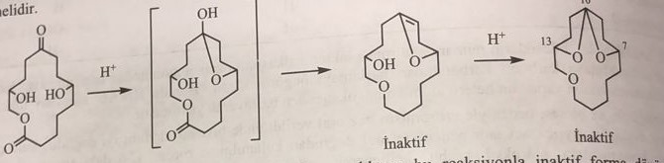
Erythromycin is labile to gastric juice. It turns into an inactive form by a reaction that takes place in an environment of pH=4. The best chemical stability is observed in C7 and C10 derivatives.
Macrolide antibiotics are used to treat infections caused by gram(+) bacteria (for example, Streptococcus pneumoniae) and gram(-) bacteria (for example, Haemophilus influenzae), as well as some infections of the respiratory tract and soft tissues. The antimicrobial spectrum of macrolides is somewhat wider than that of penicillins, which is why macrolides are used in patients with penicillin allergy. Beta-hemolytic streptococci, pneumococci, staphylococci and enterococci are usually sensitive to macrolides. Unlike penicillin, macrolides are effective against Legionella pneumophila, mycoplasma, mycobacteria, some rickettsiae and chlamydiae. Macrolides should not be used for ruminant animals such as horses and rabbits. They quickly cause a reaction that causes fatal upset stomach. Macrolides can be administered in various ways, including tablets, capsules, suspensions, injections and locally.
Erythromycin is used for the synthesis of synthetic derivatives. Roxithromycin is obtained by the reaction of the carbonyl ketone in the tenth position of erythromycin with alkoxyamine. Hydroxylamine is obtained by the reaction of triethylamine with 2-(methoxyethyl)chloromethyl ether in the medium of sodium bicarbonate to obtain alkoxyamine. Then they get an ox reaction with erythromycin. Since the (Z)-isomer of roxithromycin is more active than the (E)-isomer, it crystallizes in the form of the Z-isomer.
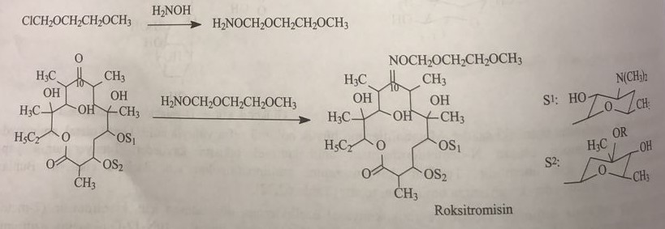
For the synthesis of dirithromycin, first, the oxime of erythromycin in the tenth position is prepared with hydroxylamine, and by its reduction, the amino group is obtained. The drug is obtained by the reaction of this derived amine with 2-(2-methoxyethoxy)acetaldehyde.
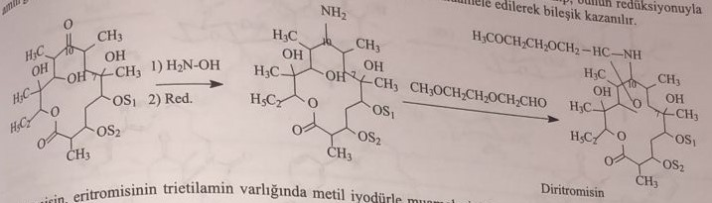
As a result of the reaction of clarithromycin erythromycin with methyl iodide in triethylamine medium, the drug is obtained by methylation of the seventh position.
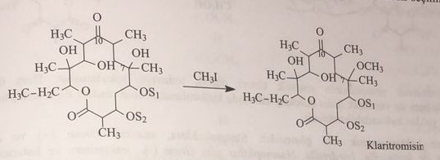
Azithromycin is 11-azo-10-deoxy-homoerythromycin. For its synthesis, oxime derivative is obtained by reacting with hydroxylamine in the tenth position of erythromycin. 11-azahomoerythromycin is prepared by heating the processed oxime derivative in an acidic environment and expanding the ring as a result of the Beckmann transformation. Its state is reduced and the resulting secondary metabolite is methylated with methyl iodide.
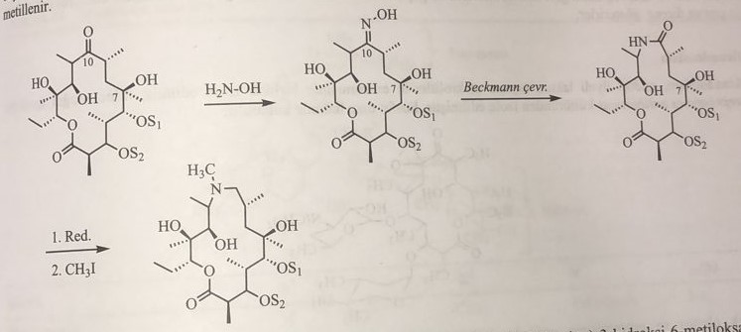
Telithromycin: (1S,2R,5R,7R,8R,9S,11R,13R,14R)-8-[(2S,3R,4S,6R)-4-dimethylamino-3-hydroxy-6-methyl-oxane-2 -yl]oxy-2-ethyl-9-methoxy-1,5,7,9,11,13-hexamethyl-15-[4-(4-pyridin-3-ylimidazol-1-yl)butyl]-3, 17-dioxa-15- azabicyclo[12.3.0]heptadecane-4,6,12,16-tetron
Synthesis of telithromycin:
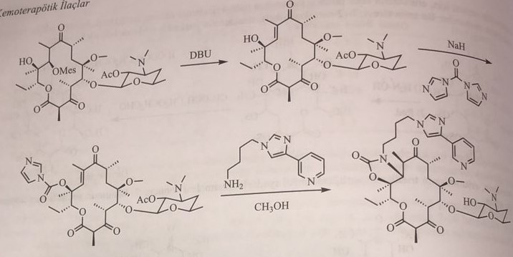
In 2007, synthetic derivatives of erythromycin were introduced into medical practice. It is also used in upper respiratory tract and soft tissue infections.
They have a bacteriostatic effect on aerobic bacteria. They affect streptococci, anaerobic gram(+) bacteria and gram(-) bacteria such as Bacillus anthracis, propionibacterien, lengionella, bordetella, Hemophilus, microorganisms without a cell wall such as listerien, chlamydia and mycoplasma. They are active against Toxoplasma gondii. They act by inhibiting bacterial protein synthesis. They stop the elongation process by inhibiting translocation. Antibiotics such as lincomycin and chloramphenicol, oxazolidine and streptogramin also cause cross-resistance because they affect the joining point of peptidyl transferase enzyme.
Oleandomycin
Oleandomycin belongs to the macrolide group of antibiotics containing a 14-membered lactone ring, and is the second natural representative of this group, isolated along with erythromycin. It is isolated from Streptomyces antibioticus culture. It is used in the form of phosphate salt.
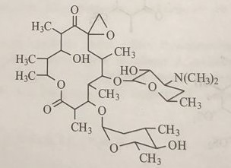
It is not used in clinical practice due to its toxicity and antibacterial action similar to erythromycin. He was included in the experiment under the name triacetyloleandomycin. It has a negative effect on the blood clotting system.
16-member group of macrolide antibiotics
Clinical practice includes two main representatives of this group. Leukomycin was isolated from the culture of Streptomyces kitasatoeusis, and spiramycin - from the culture of Streptomyces ambofacieus. Various derivatives were obtained by acylation of the hydroxyl group of products obtained from this Streptomyces culture. Derivatives of leukomycin and spiramycin are listed in the table. 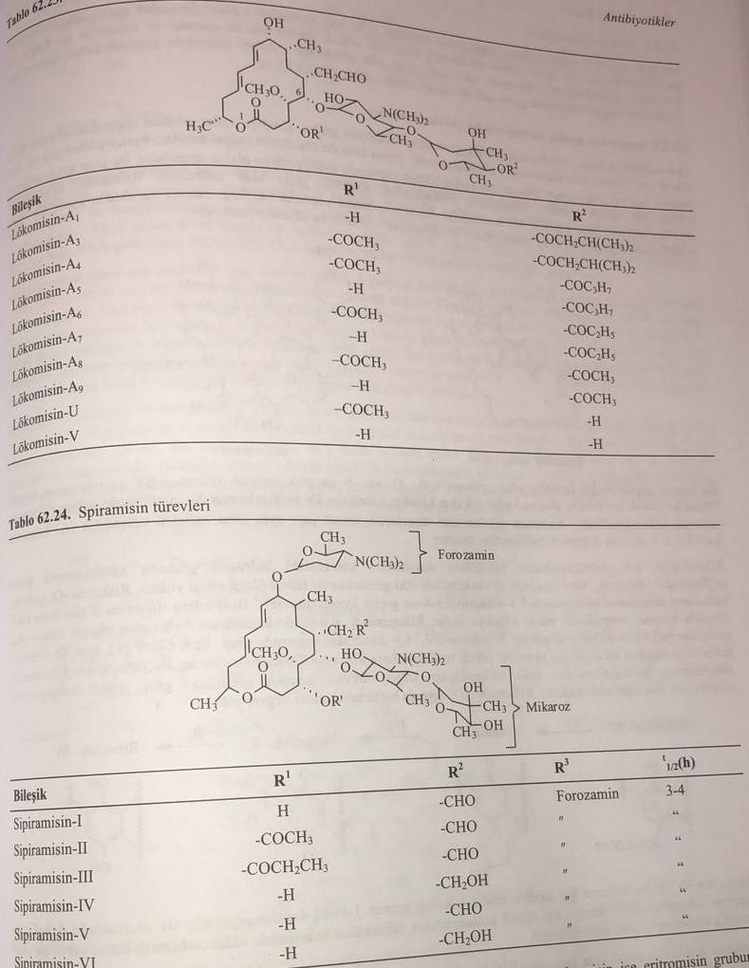
Polyene macrolides
This group of macrolide antibiotics is called polyene antibiotics because they contain a conjugated double bond in their molecule. The most important representatives of this group are amphotericin-B, nystatin and natamycin. In addition to antibacterial action, this group of compounds also has antifungal action.
Antibiotics of the ansamycin group (macrolactam)
The rifamycin group, which is a macrocyclic macrolide antibiotic compound, contains naphthohydroxynon and various double bonds in its molecule. At the same time, cyclization occurred through an amide (peptide) bond. Rifampicin is obtained by semisynthesis from rifamycin. Rifamycin is a macrolide obtained from Streptomyces mediterranii. If you look at the basic structure of rifamycin, these compounds are called ansamycins (ansa means "to hold" in Latin), because they resemble a pitcher.
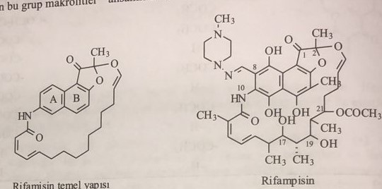
In this group, different natural representatives rifamycin-B,-O- and -S- and synthetic representatives rifamycin-SV and rifampicin are grouped. All the derivatives listed above have the same basic structure and are composed of a naphthalene ring. The eighth position of this ring is very active and substitutions almost always occur in this position.
A carboxymethyl group is attached to the hydroxyl group in the ninth position of the 6,9-dihydroxynaphthalene ring of the rifamycin-B molecule. Although this derivative shows partial activity against gram(+) bacteria, it does not affect tubercle bacilli. It is a derivative that retains a 1,3-dioxoliden-4-one group in the ninth position of the naphthacene ring of the rifamycin-O molecule. It is less active against bacteria than rifampicin-B. Rifamycin-S is an oxidized derivative of the 6,9-dihydroxynaphthalene ring and has a very low antibacterial effect. Rifamycin-SV has a 6,9-dihydroxy structure and is highly active against both gram(+) and gram(-) bacteria. These derivatives are converted into each other by various reactions. Among these derivatives, rifamycin-B was isolated from Streptomyces mediterranei culture. Other derivatives are obtained from rifamycin A by various reactions as shown in the scheme. Except for Rifamycin-SV, none of them have a strong antibacterial effect.
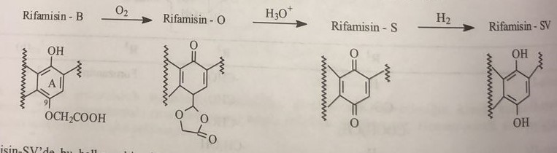
In this ring, the aldehyde rifamycin-SV is inserted, and its derivative Schiff base with 1-methyl-4-aminopiperazine is called rifampicin-RMP. Suitable for oral use, used in the treatment of tuberculosis and is a synthetic antibiotic of the ansamycin group.
Rifamycin-СВ is used for the synthesis of rifampicin-РМФ. To do this, the aminomethylation reaction in the eighth position with pyrrolidine/formaldehyde is first carried out, and then the oxidation of lead tetraacetate is carried out. Thus, 8-formylrifamycin-СВ is obtained. As a result of its reaction with 4-amino-4-methylpiperazine, rifampicin-PMB is obtained. 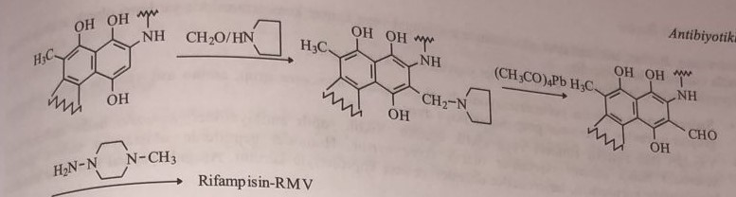
For antimycobacterial activity of rifampicin, hydroxyl groups in the seventeenth and nineteenth positions and phenolic hydroxyl groups in the fifth and sixth positions of the naphthalene ring must be located in the same plane. Physico-chemical and pharmacokinetic properties depend on functional groups attached to the eighth position of the naphthalene ring. Rifampicin was recognized as the most suitable and active compound among approximately one hundred derivatives. Rifampicin activates DNA-dependent RNA polymerase, blocks RNA synthesis and has an antibacterial effect.
It is quickly and completely absorbed from the gastrointestinal tract. Thanks to its lipophilic properties, rifampicin is perfectly distributed in tissues. It penetrates well into almost all body fluids, including the cerebrospinal fluid. It passes into the placenta. Its binding to proteins is 60-90%. Oral bioabsorption is 90-95%. The speed and degree of suction depend on the intake of food. About 40% of the drug is excreted from the body through the kidneys.
The first metabolite in its biotransformation is the product formed as a result of hydrolysis of the acetyl group on carbon C25. After ingestion, the absorbed rifampicin is deacetylated by oxidative microsomal enzymes in the liver with the formation of the active metabolite 25-O-desacetylrifampicin. 80% of this metabolite enters the intestines through the bile ducts. The second metabolite is formed during oxidative hydrolysis of hydrazone. As a result of hydrolysis, inactive 3-formylrifamycin is found in the urine. The glucuronide conjugate is formed as a result of the enterohepatic cycle. Long-term treatment with rifampicin causes induction of liver enzymes. Therefore, it is recommended to increase the dose during treatment.
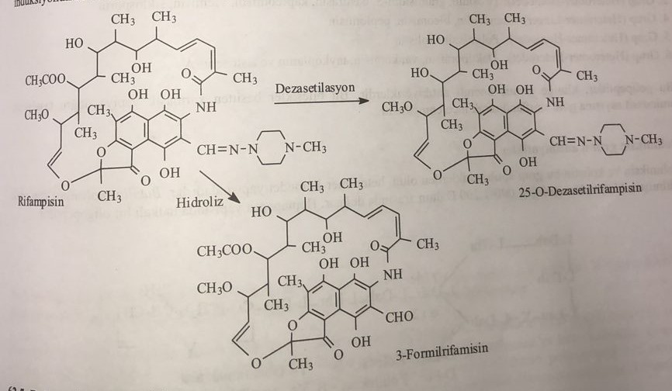
Polypeptide antibiotics
This group of compounds includes peptide and glycopeptide antibiotics. Some peptide antibiotics are used locally. However, there are representatives whose system is effective. After the discovery of bacitracin in 1945. more than 200 antibacterial oligopeptides and polypeptides were discovered, some of which entered clinical practice. They are used as an auxiliary drug in the treatment of antifungal or tumor diseases under the special supervision of a doctor.
These antibiotics, known by their polypeptide structure, are structurally characterized:
1) If it is formed as a result of the polymerization of only amino acids, then the homomeric group is divided into two groups, the heteromeric group, if different monomers are added during polymerization in addition to amino acids.
2) The molecule has an open or cyclic chain. Cyclic antibiotics are divided into two groups: antibiotics with a homodetermining system of rings and antibiotics with a heterodetermining system of rings. In homodetic peptides, cyclization is established only by sulfhydryl bridges, while in heterodetics, complex ester and ether bridges are also observed.
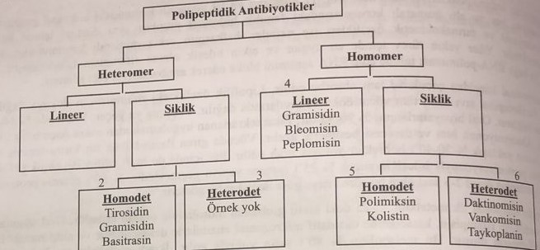
There are no compounds that are used as antibacterial agents from the heteromeric first group in the open structure and the heterodet third group in the cyclic structure.
Second group (Heteromer-Homodeta): Tyrosidine, gramicidin-S, bacitracin, capreomycin, viomycin, cyclosporine.
The fourth group (heteromer-open): gramicidin, bleomycin, peplomycin.
Fifth group (heteromer-homodet): polymyxin, colistin.
The sixth group (heteromer-heterodeficiency): dactinomycin, vancomycin, tycoplanin and ristocetin-A.
These polypeptides are important antibiotics included in clinical practice.
Polymyxin group of antibiotics
Polymyxin or colistin belongs to this group of antibiotics and has a heteromeric-homodetic structure. It was isolated from Bacillus polymyxa. Its molecular weight is from 1000 to 1200 daltons. This is a ring oligopeptide with a heptapeptide structure.
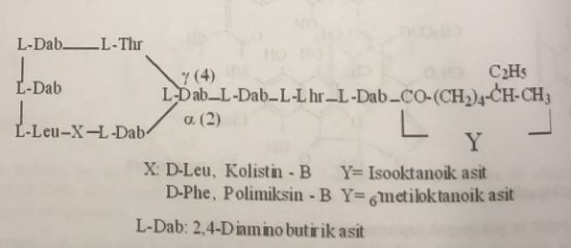
They are active against gram (-) bacteria, especially blue bacillus, enterobacteria, Escherichia coli, hemophilic bacillus, salmonella and shigella, increasing the permeability of the cell membrane. They are used both orally and locally. When used orally, the sulfate salt is not absorbed by the body. It is used as an intestinal antiseptic. Polymyxin is especially contained in eye and ear drops. In high doses, it causes nephrotoxicity and neurotoxicity.
Viomycin and capreomycin
The main signs are cyclic compounds. It has a homomeric-homodetic structure. These bacteriostatic preparations have high activity against mycobacteria. This is the third drug of choice after streptomycin in the treatment of tuberculosis. They have an inhibitory effect on the synthesis of ribosomal enzymes.
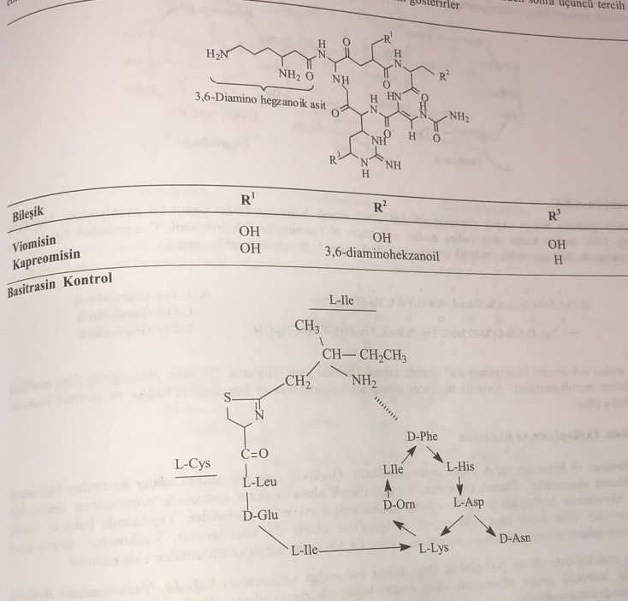
The molecule consists of seven amino acids, cyclically homogenized. Lysine plays a binding role. The amino acid L-isoleucine is connected at the N-end with a molecular coordination bond with D-phenylalanine in a cyclic structure.
This is an antibiotic isolated from Bacillus subtilis, which has a homomer-homodet structure. It is mainly used locally. It is effective against gram (+) bacteria. It is used against Neisseria and Haemophilus influenza. Not active against gram(-) bacteria. It inhibits the synthesis of polypeptide glycans that form the cell wall of bacteria. It has a nephrotoxic effect. It is used topically and is available in preparations in combination with neomycin.
Thyrotricin and Gramicid-S
This is an antibiotic with a homomer-homodet structure. Produced from Bacillus brevis. This is a decapeptide consisting of eight L-amino acids and two D-amino acids. Gramicidin S is similar to tyrosine. Tyrosidine consists of two carboxyl groups and one basic molecule of ornithine. This carboxyl group is neutralized by amines. The compound isolated from the Bacillus brevis culture is called thyrothricin. This compound consists of a mixture of tyrosidine A, B and C, and the main substance is tyrosidine A. It activates the structure L-Phe-D-Phe, L-Tyr-D-Phe in tyrosidine B and L-Try-D-Try in tyrosidine C. In clinical practice, the mixture of tyrothyricin:gramicidin (20:80) is used. It affects gram (+) bacteria. Since it has a hemolytic effect, it is mainly used locally. It is applied in the form of 0.1% ointment and cream.
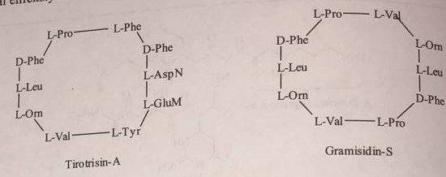
Gramicidin-А, В, С
Unlike gramicidin-S, whose structure is similar to the group of tyrothricins, it is an antibiotic with an open homomeric structure. Its molecular mass is 1000 mol/g. It consists of 15 amino acids. 2-hydroxyethyl is attached to the N-end, and the formyl group is attached to the C-end. In some gramicidins, the first amino acid is L-isoleucine instead of L-valine.
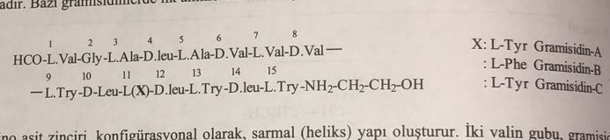
Acid chains D and L form a helical structure configurationally. The gramicidin molecule, containing two valine groups, forms a channel in the pores of the bacterial cell membrane, allowing the cytoplasm to empty, and thus the bactericidal effect is manifested.
Vancomycin, tycoplanin and ristocetin
They are antibiotics with cyclic heteromer and heterodet structures. In particular, they combine over aromatic amino acids to form a cyclic structure. It has an antibacterial effect by inhibiting the combination of subgroups in the proteoglycan chain in the synthesis of murein, which is formed depending on the plasma membrane. Sugars are attached to the phenolic groups in its molecule, so glycopeptides are included in the group of antibiotics. Vancomycin is obtained from the culture of Streptomyces orientalis, teicoplanin from Actinoplanes teichomyceticus, ristocetin from Nocardia lurida.
The first sugar in the vancomycin molecule is β-D-glucose, and vancosamine is attached to the second position. The hydroxyl group in the fourth position of vancosamine is equatorial and is called 4-epivancosamine. Vancomycin contains a very small amount of epivancomycin.
The spectrum of influence is quite wide. It is active against both aerobic and anaerobic gram(+) bacteria. In particular, they have a bactericidal effect against staphylococcus, enterococcus and Lostridium difficile. They are used for infections caused by methicillin-resistant staphylococcal strains.
Due to the glycopeptide structure, they are poorly absorbed when used orally. Therefore, they are used parenterally. Vancomycin has a half-life of seven hours, while teicoplanin has a half-life of 70 hours. They are excreted from the body mainly through urine. They have an ototoxic effect depending on the dose.
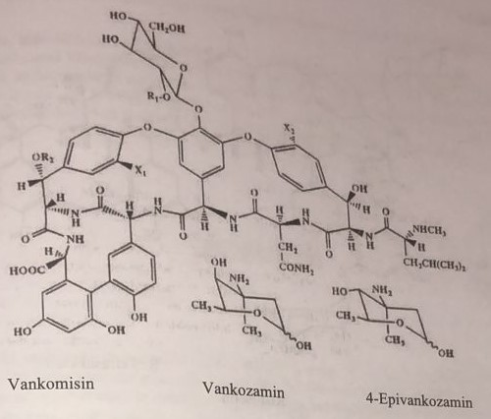
In the tycoplanin molecule, three sugars are attached to the peptide aglycone at three different points, two of which are amino sugars and the other is β-D-mannose. Therefore, these antibiotics are also called peptide aminoglycosides.
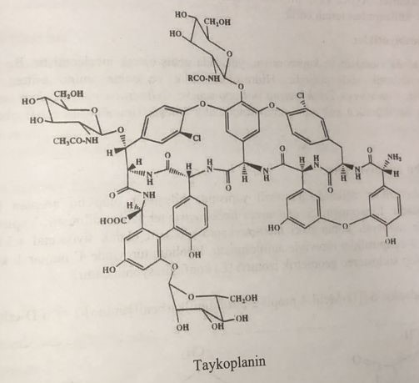
2-О-α-(2-О-α-D-arabinosyl-D-mannosyl)-6-О-α-(L-rhamnosyl)-β-D-glucose tetrasaccharide attached to the ristocetin molecule, unlike the peptide aglycon ticoplanin. It is highly active against actively multiplying gram(+) bacteria. They inhibit transpeptidase acting on D-alanine-D-alanine in cell wall synthesis. The effects are similar to the mechanism of action of β-lactam antibiotics.
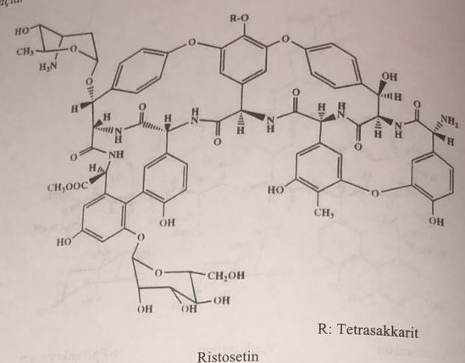
β-lactam antibiotics act by direct binding to the enzyme. These compounds behave as substrates of this enzyme. Since parenteral drugs are broad-spectrum antibiotics, these compounds are prescribed for severe infections. Glycopeptides are inactive compounds when used orally.
Other cyclic peptide antibiotics
Viomycin and capreomycin in the homomer-homodet structure are described in detail above. Cyclosporin is an important peptide antibiotic not mentioned in this group. This is a peptide consisting of a hydrophobic ring and 11 amino acids. Tolipocladium inflatum, Gams and Trichoderma polysporum and Cylindrocarpon lucidum were obtained from box culture. In addition to antibacterial properties, it is an effective immunomodulating drug.
Lincosamide group of antibiotics
Antibiotics of the group of lincosamides are compounds of acylaminopyranoside structure. Representatives of this group are lincomycin and clindomycin. Lincomycin was isolated in the culture of Streptomyces lincolnensis. It contains 8-carbon sugar in its structure. In the first case, methylmercaptoglycoside is in the thioacetal form. The amino group in the sixth position is amidated with derivatives of 3-acylpyrrolidine. The propyl group in the fourth position of the pyrrolidine derivative is in the trans position. The cyclostereogeometric isomer is in configuration (Е).
Lincomycin: methyl-6,8-dideoxy-6-[(1-methyl-4-propylprolyl)amino]-1-thioctopyranoside
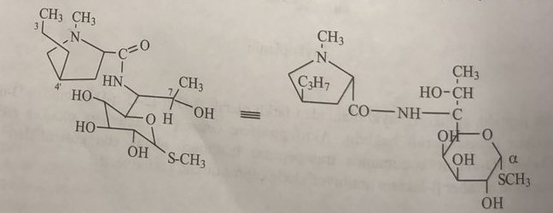
Clindamycin: methyl-7-chloro-6,7,8-trideoxy-6-(1-methyl-trans-4-propyl-L-2-pyrrolidinecarboxamido)-1-thio-L-threo-α-D-galactooctopyranoside
Lincomycin is used as a starting material for the synthesis of clindamycin. Lincomycin interacts with gaseous chlorine in an acetonitrile solvent in the medium of triphenylphosphate with the formation of clindamycin by chlorination of the hydroxyl of the double alcohol in the seventh position. For him, this compound is a semisynthetic antibiotic of the licosamide group. However, this reaction of halogenation occurs with the inversion of the stereochemistry of the molecule, and the compound turns into configuration (7S). Changing this configuration increases the activity of the connection by 4-5 times. This reaction takes place in the seventh state of the molecule and is specific.
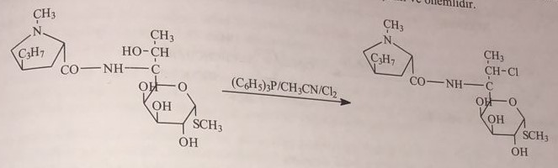
Both representatives of this group are used parenterally in the form of chloride salt. Oral bioavailability is also quite high. The bases of clindamycin and lincomycin are lipophilic. The plasma half-life is 2-3 hours for clindamycin and 5 hours for lincomycin. At the same time, they interact with nutrients. A higher plasma concentration of clindamycin is reached when taken with food. In addition to being active against gram(+) bacteria, they are also effective against mycoplasma. Lincomycin and clindamycin affect the synthesis of bacterial protein. They affect the 50S-ribosomes of gram(+) bacteria. They do not work on gram(-) bacteria. The metabolite of phase 1, formed as a result of N-demethylation and oxidation reactions, has a sulfoxide structure.
Chloramphenicol and its derivatives
Chloramphenicol was obtained from the culture of Streptomyces venezuelae in 1947. At present, it is obtained by synthesis. These antibiotics have a very broad spectrum of action. Other representatives of this group are thiamphenicol and azidamphenicol. In 1949, Park-Davis hydrolyzed natural chloramphenicol by an alkaline method and found that the amino group in phenylpropanolamine is acylated by dichloroacetic acid. Oxidation with iodine acid gives 4-nitrobenzaldehyde. It was established that the two carbon atoms in propanolamine are asymmetric and have the configuration (1R,2R) and D-treoform due to two neighboring asymmetric atoms.
Chloramphenicol: (1R,2R)D-threo-2,2-dichloro-N-[2-hydroxy-1-(hydroxymethyl)-2-(4-nitrophenyl)ethyl]acetamide
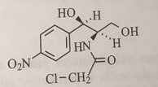
Chloramphenicol is obtained in two ways.
1) Park-Davis method
2) Beringen-Mannheim method
Park-Davis method
This method is also called the 4-nitroacetaphenone method. First, 4-nitroacetaphenone is brominated, and 3-amino-4-nitroacetaphenone is obtained with sonar urotropin. After protection of the amino group by acetylation, hydroxymethylation with formaldehyde and hydrolysis of the acetyl group, the intermediate product is treated with D-camphor sulfonic acid, its diastereoisomer is obtained and optical separation is carried out. Chloramphenicol is obtained as a result of the reaction with methyldichloroacetate.
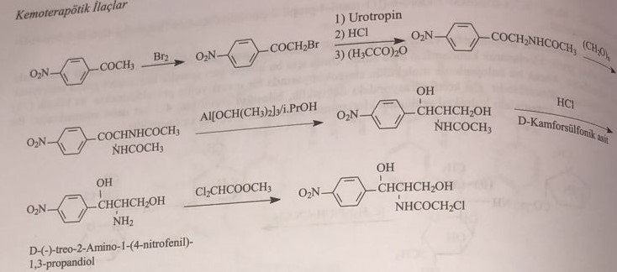
Method Behringer-Manheim
This is also called the cinnamon alcohol method. First, cinnamic alcohol is brominated to give 2-bromo-1-phenyl-1,3-propanediol. Then they get 5-bromo-2,2-dimethyl-4-phenyl-1,3-dioxane with ketone and add an amino group in the fifth position in the presence of ammonia. Stereoisomers with D-tartaric acid give D-(-)-threo-5-amino-2,2-dimethyl-4-phenyl-1,3-dioxane. The amino group is acylated with ethyldichloroacetate and p-nitrophenyl derivative is obtained with nitric acid, and the isopropylidene group is removed to obtain chloramphenicol.
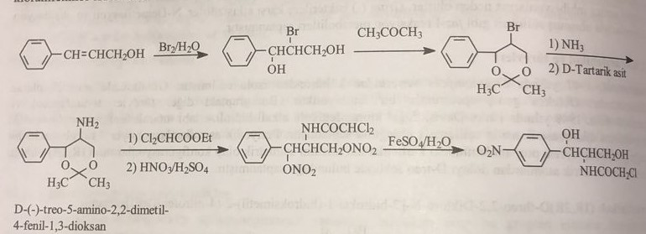
Chloramphenicol is an antibiotic used to treat a number of bacterial infections. This includes using it as an eye ointment for the treatment of conjunctivitis. It is prescribed as oral or intravenous injections for meningitis, plague, cholera and typhoid fever. During treatment, it is recommended to monitor both the level of the drug in the blood and the level of the formed elements of the blood daily. Common side effects include bone marrow depression, nausea, and diarrhea. Bone marrow suppression can be fatal. The duration of treatment should be as short as possible to reduce the risk of side effects. People with liver or kidney problems need lower doses. In infants, a condition known as gray baby syndrome can lead to abdominal distension and low blood pressure. The use of the drug near the end of pregnancy and during lactation is usually not recommended. Chloramphenicol is a broad-spectrum antibiotic, the action of which usually consists in stopping protein synthesis. Chloramphenicol was discovered in 1947 after its isolation from Streptomyces venezuelae. Its chemical structure was determined and synthesized for the first time in 1949. It is included in the list of essential drugs of the World Health Organization.
Thiamphenicol: (1R,2R)D-(+)-threo-2,2-dichloro-N-[2-hydroxy-1-(hydroxymethyl)-2-(4-methylsulfonylphenyl)ethyl]acetamide
The synthesis compound is shown below:
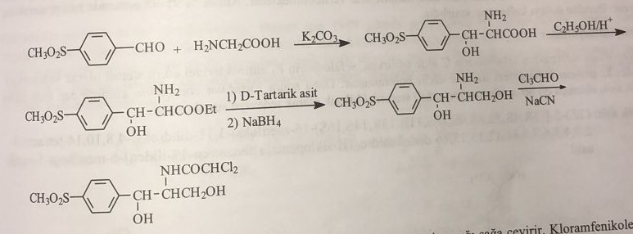
This is a synthetically obtained compound similar to chloramphenicol. Rotates the plane of polarized light to the right. It is more soluble in water than chloramphenicol. The combination of plasma columns is 10%. It is mostly excreted in the urine. It is used to treat urinary tract infections caused by gram(-) bacteria.
Azidaphenicol
The synthesis connection looks like this:
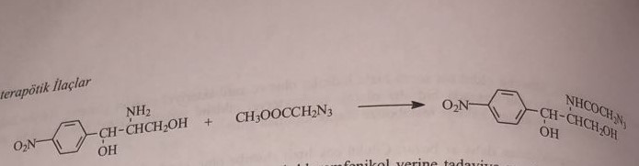
It was synthesized by the Bayer company in 1960. Azidamphenicol is used to eliminate bone marrow depression caused by chloramphenicol.
Antibiotics of different structure
Novobiosin, steroid antibiotics, muspirocin, fosfomycin, cycloserine are the most important compounds of this group.
Novobiazine
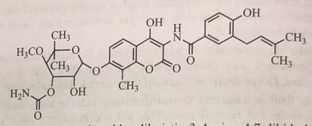
Novobiosin, also known as albamycin or catomycin, is an aminocoumarin antibiotic synthesized by Streptomyces niveus. Other aminocoumarin antibiotics include chlorobiocin and coumermycin A1. Novobiosin was first discovered in the mid-1950s. Active against epidermal staphylococcus. Novobiosin was licensed for clinical use in the 1960s under the trade name albamycin (Upjohn). Its effectiveness is proven in preclinical and clinical studies. Novobiosin is an effective antistaphylococcal agent used in the treatment of infectious diseases.
Steroid antibiotics
Along with cephalosporin C, cephalosporin P1 was also isolated from Cephalosporium species. Cephalosporin P1 was identified as an antibacterial substance with a steroid structure. Fusidic acid, then obtained from the culture of Fusidium coccineum, is a highly active antibacterial compound.
Fusidic acid
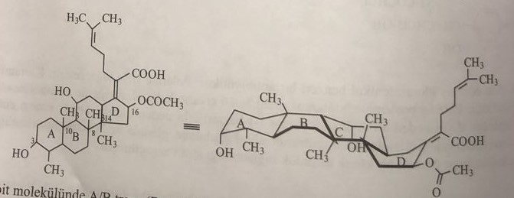
The normal steroid molecule has A/B (B-anti), B/C-trans (C-anti) and C/D-trans-linkages. Fusidic acid has a steroid structure A/B trans, (B syn), B/C trans (C anti), C/D trans. The methylene group in the eighth position and the methylene group in the fourth position are in the anti-configuration, and ring B is in the boat configuration.
Fusidic acid is used in patients with penicillin allergy. It acts as an inhibitor of protein biosynthesis.
Mupirocin: trans-pseudomonic acid
Obtained from culture of Pseudomonas flurescens. It is an ester formed from 9-hydroxynonanoic acid and monoic acid. It is active against staphylococcus and streptococcus. Isoleucine acts as a competitive inhibitor of t-RNA synthetase enzyme and inhibits bacterial protein synthesis. It is especially used in dermal infections. It is used in medical practice as a locally effective preparation rather than a systemic one.
Fosfomycin:(-) (1R,2S) (1,2-Epoxypropyl)phosphoric acid
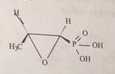
It is a secondary metabolite obtained from culture of Streptomyces fradie and Streptomyces virido-chromogenes. It enters the cell by active transport. It is a broad-spectrum antibiotic. It inhibits peptidoglycan biosynthesis and prevents the formation of the bacterial cell wall. Fosfomycin is an antimetabolite of the enol of phosphogravic acid. By inactivating pyruvyl transferase, it prevents the catalysis of N-acetylglucosamine by phosphoenolpyruvate to N-acetylmuramic acid in bacteria. Oral bioabsorption is poor. It is used in the form of sodium salt.
Fosfomycin synthesis is as follows:
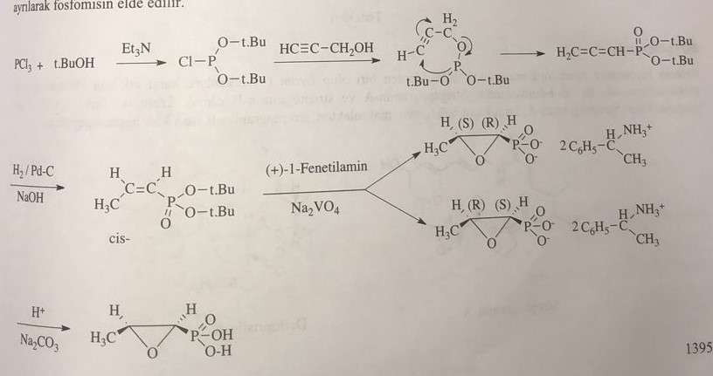
D-Cycloserine: D-4-Amino-3-isoxazolidinone
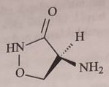
Streptomyces garyphalus was isolated from cultures such as S. Orchidaceus and S. Lavendulae in 1952-1954. It is obtained synthetically.
The synthesis of the preparation is as follows:
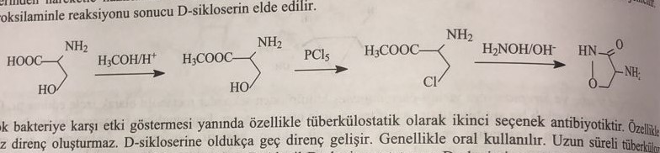
Streptogramin
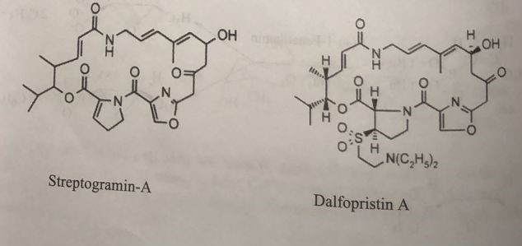
As an inhibitor of protein synthesis, it is used in the treatment of infectious diseases caused by Gram(+) bacteria. Streptogramin A and streptogramin B are composed of two different cyclic structures. Streptogramin A is a macrolactone composed of multiple double bonds, while streptogramin B is a cyclic hexadipeptide. Since they do not dissolve well in water, derivatives that can be used parenterally have been synthesized. Streptogramin A derivatives include dalfopristin, and streptogramin B derivatives include quinupristin.
